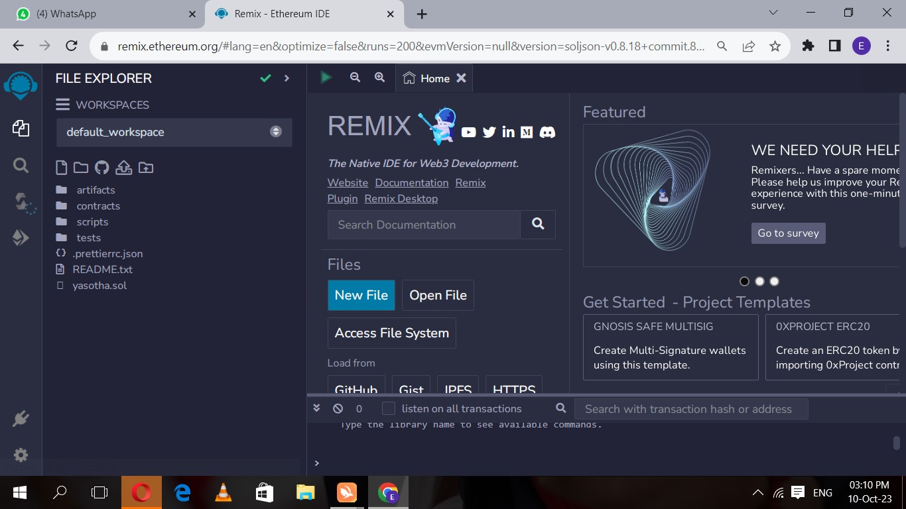

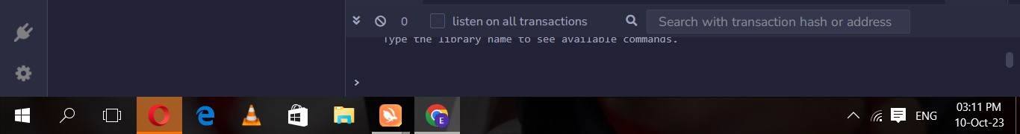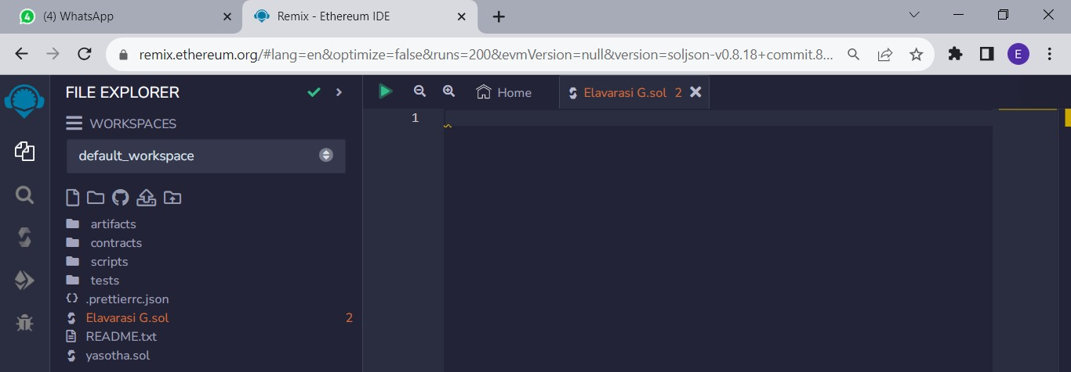

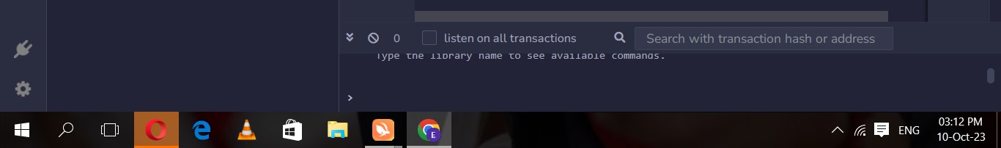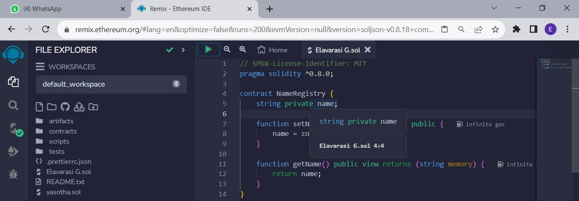

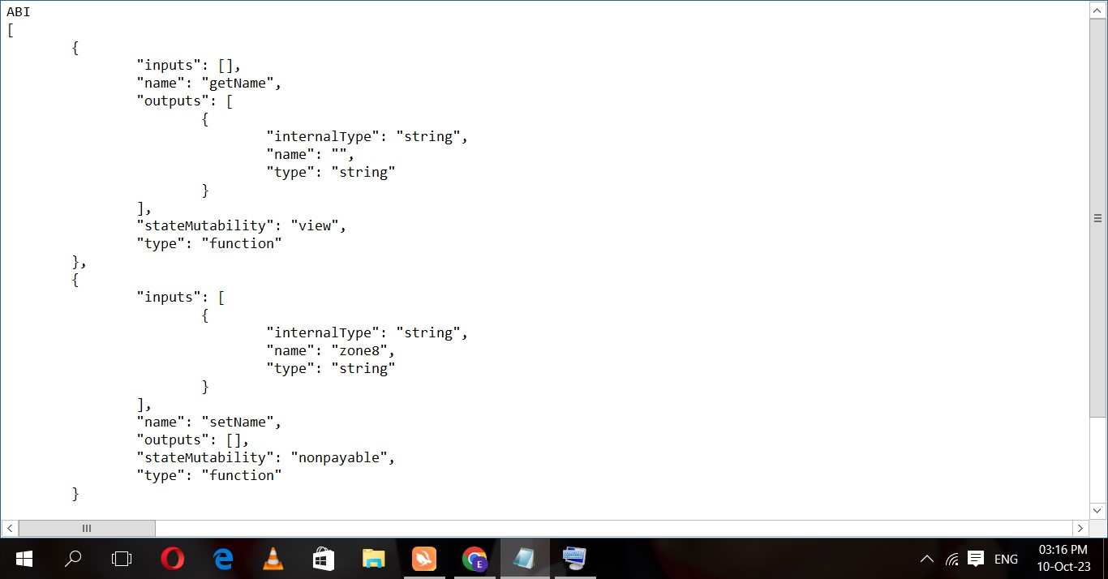 New Text Document - Notepad x

File Edit Format View Help

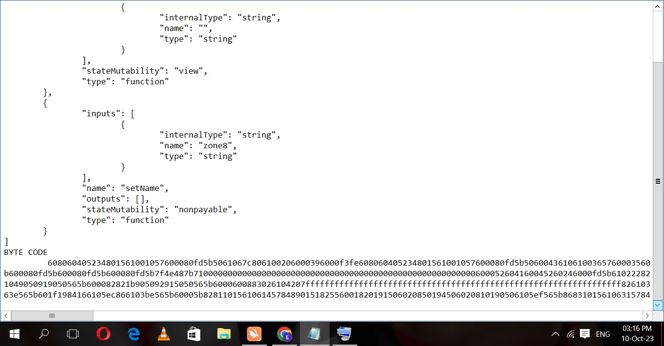 New Text Document - Notepad x

File Edit Format View Help

O (4) WhatsApp Remix - Ethereum IDE

DEPLOY & RUN TRANSACTIONS

ENVIRONMENT

Remix VM (Shanghai) i

ACCOUNT O

Ox5B3...eddC4 (99.999999

GAS LIMIT

3000000

VALUE

Wei

# CONTRACT

NameRegistry - Elavarasi G.sol

Wm pans

Publish to IPFS

 Home Elavarasi G sol X

## 1 SPDX-License-Identifier: MIT

2 pragma solidity nø.8.ø;

3

4 contract NameRegistry {

## 5 string private name;

6

1. function setName(string memory zone8) public { infinite gas
2. name = zone8;
3. listen on all transactions Q Search with transaction hash or address data : øx6Ø8. . .2eø33 logs: hash: ØxeeØ.. . bdd74

### true Transaction mined and execution succeed

|  |  |
| --- | --- |
| transaction hash | exeeø5ecec5e3f8bd773f152cgaøæc3ea13bbe2bad37ø9c726c14ø272ø5abdd74 |
| block hash  block nunber | exb66fac7e3514d56d17a88decf7fecb1722d415ace2372bø65de3d2b71da697af |
| contract address | exd9145CCE52D386f254917e481e344e9943F39138 |

ex5838Da6a7ø1c568545dcfcBø3FcB875f56beddC4

03:17